**lAB 3**

**COAL**

**21k 4834**

**QUESTION 1**

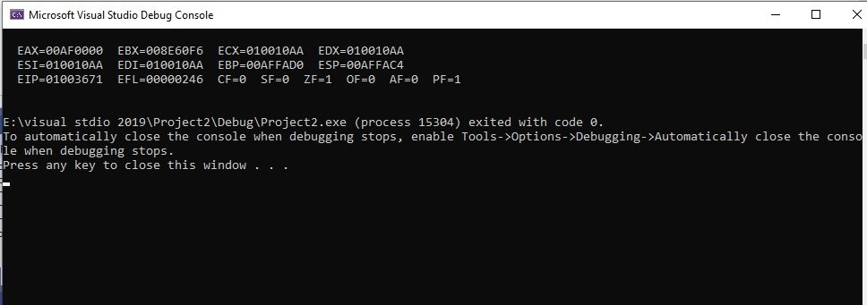

INCLUDE Irvine32.inc

.data

val1 SWORD ?

val2 SBYTE -10

.code

main PROC

mov ax,val1

mov b1,val2

call DumpRegs

exit

main ENDP

END main

**QUESTION 2**

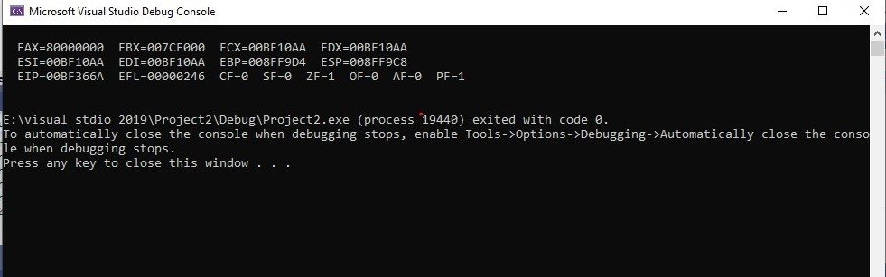TITLE task (Test.asm)

INCLUDE Irvine32.inc

.data

val3 SDWORD -2147483648

.code

main PROC

mov eax,val3

call DumpRegs

exit

main ENDP

END main

**QUESTION 3**

TITLE task (Test.asm)

INCLUDE Irvine32.inc

.data

arr WORD 1,2,3

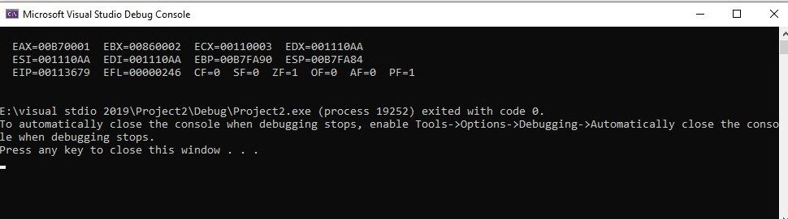

.code

main PROC

mov ax,arr[0]

mov bx,arr[2]

mov cx,arr[4]

call DumpRegs

exit

main ENDP

END main

**QUESTION 4**

INCLUDE Irvine32.inc

.data

msg BYTE "GRAY" ,0

val1 WORD 12

val2 WORD 2

val3 WORD 13

val4 WORD 8

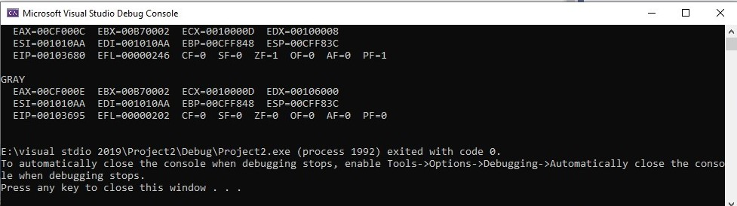

val5 WORD 14

.code

main PROC

mov ax,val1

mov bx,val2

mov cx,val3

mov dx,val4

call DumpRegs

mov ax,val5

mov edx,offset msg

call WriteString

call DumpRegs

exit

main ENDP

END main

**QUESTION 5**

INCLUDE Irvine32.inc

.data

a WORD 10

b WORD 15

cw WORD 20

d WORD 30

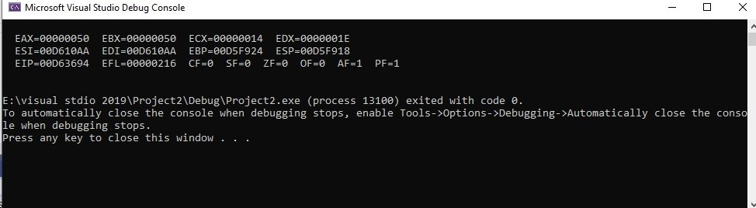

.code

main PROC

movzx eax,a

movzx ebx,b

movzx ecx,a

movzx edx,d

add eax,ebx

sub ecx,ebx

sub eax,ecx

movzx ecx,cw

add eax,ecx

add eax,edx

mov ebx,eax

call DumpRegs

exit

main ENDP

END main

**QUESTION 6**

INCLUDE Irvine32.inc

.data

a BYTE 00010000b

b BYTE 00010101b

c BYTE 00100000b

d BYTE 00110000b

.code

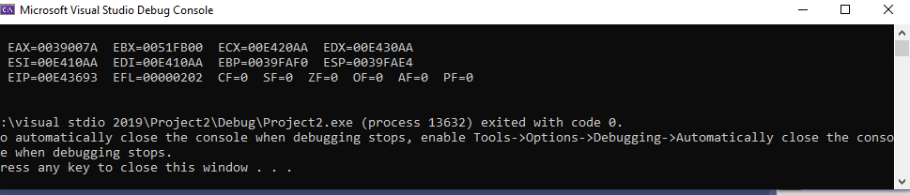

main PROC

mov ah, a

add ah, b

mov bh, a

sub bh, b

sub ah,bh

mov ch, c

mov dh, d

add ah,ch

add ah,dh

movzx ax, ah

call DumpRegs

exit

main ENDP

END main

**QUESTION 7**

INCLUDE Irvine32.inc

.data

A word 20

Data1 word 8

Data2 word 15

Data3 Word 20

.code

main PROC

movzx eax,A

movzx ebx,Data1

add eax,ebx

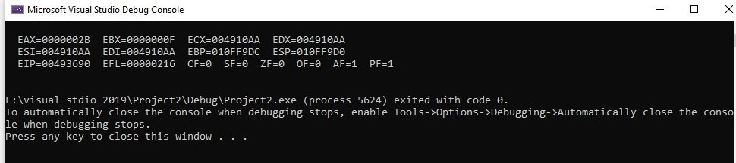

movzx ebx,Data3

sub eax,ebx

movzx ebx,A

add eax,ebx

movzx ebx,Data2

add eax,ebx

call DumpRegs

exit

main ENDP

END main